**Clinical Pharmacokinetics**

**Pharmacokinetics changes and dosing in liver disease**

**Christina Rose, PharmD, BCPS**

**______________________________________________________________________**

Goal: Anticipate when alterations in hepatic function will necessitate dosing adjustments to maintain desired effects of drug therapy.

Objectives:

At the end of this lecture students should be able to:

1. List three primary variables affecting hepatic clearance of drugs.
2. Describe pharmacokinetic changes that occur in a patient with cirrhosis.
3. Determine drug dosing based on Child-Pugh score.
4. Given a drug’s pharmacokinetic properties and the severity of a patient’s liver disease, determine if a specific drug will need to be dose adjusted.

Clinical problem: There is no simple marker to predict liver function.

1. Functions of the liver

Synthesis of proteins

Metabolism of drugs

B. Liver disease and hepatic function

1. Acute hepatitis: drug elim is not effected

2. Chronic hepatitis

3. Hepatic cancer

4. Cirrhosis

a. permanent loss of hepatocyte function

b. impaired excretion of bile acids and bilirubin

c. may affect function of other organs (kidneys, lungs, intestines)

5. Cholestatic liver disease

a. ↓ formation of bile

b. ↓ elimination of bile

C. Assessment of hepatic function to determine dosing adjustments

1. Liver function tests

2. Dynamic tests (plasma clearance of antipyrine, galactose, ICG)

3. Dosing using Child Pugh Score

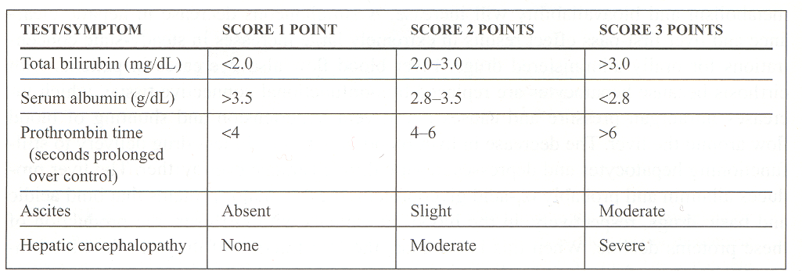

Score 5-6 normal or mild liver function (Class A)

Score 7-9 moderate (Class B)

Score > 10 severe (Class C)

Question: AS is a43 y/o male with a history of DM, HTN and chronic hepatitis C. He was admitted to the ICU with sepsis. Physical exam shows moderate ascites.

150 110 50 81 Alb 1.5 Tbili 2.5 Dbili 1.2 AST 98 ALT 102 PT 15 (12-16)

3.1 28 1.4

**Calculate the Child-pugh score for this patient.**

TYGACIL recommended dosage regimen: 100 mg initial dose, 50 mg every 12 hours

* No dose adjustment is warranted in patients with mild to moderate liver disease( Child Pugh A & B) .In severe hepatic impairment (Child Pugh C), the initial dose should be 100 mg followed by a reduced maintenance dose of 25 mg every 12 hours
* Intravenous infusions should be administered over approximately 30 to 60 minutes every 12 hours

**What dose of tigecycline (Tygacil) should be recommended for this patient?**

D. Pharmacokinetic changes in liver disease

1. Absorption
2. Physiologic/pharmacokinetic changes
3. Rate of absorption : maybe decrease
4. Bioavailability: increase b/c hindered first pass effect
5. Clinical relevance

2. Distribution

1. Physiologic/pharmacokinetic changes
2. Increase Vd of hydrophilic drugs
3. Decrease protein production/Increase fraction of unbound drug (fu)
4. Metabolism
   1. Hepatic clearance: ↓ LBF &Cl int, fu ↑
   2. Bioavailability
   3. Changes in Phase I and Phase II metabolism

Clinical problem: We do not know these patient specific values in clinical practice BUT LBF and Clint are usually decreased and fu is usually increased in cirrhosis.

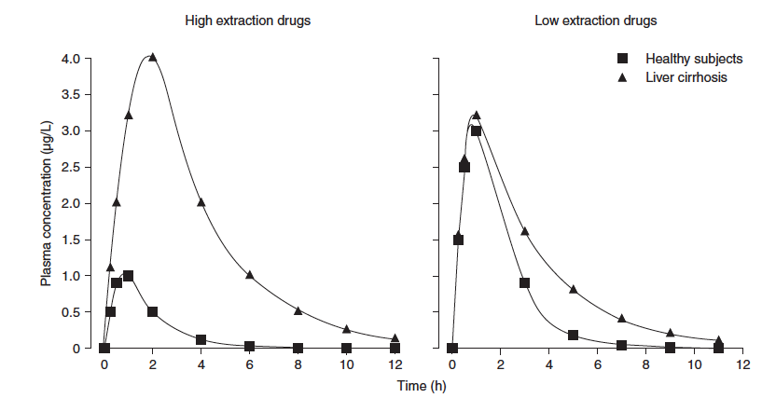

Adapted from Delco F Drug Safety 2005;28(6):529

1. Hepatic extraction ratio:

* Low hepatic extraction ratio (< 30%)
  + Examples: phenytoin, warfarin, theophylline, valproic acid
  + ClH = fu * Cl int
    - Css(total)= Dose/ ClH
    - Css(free)= fu x Css(total)

∴ In severe liver disease The change in ClH will depend on the extent Cl int and fu change but is usually decreased. Bioavailability (F) should not be affected.

**Question: Do you expect to see a change in the ClH of valproic acid in a patient with cirrhosis. How would this affect serum concentrations?**

Yes. Peak is the same (similar first pass). But elim is slower

Decrease in intrinsic clearance

* High hepatic extraction ratio (≥70%)
  + Examples: lidocaine, propranolol, morphine, most TCAs
  + Bioavailability usually decreased because of first-pass effect but should assume **no** first-pass effect occurs in cirrhotic patients
  + ClH = liver blood flow (LBF)
    - Changes in protein binding and Cl int will not change ClH,
    - Css(total)= Dose/ ClH

Css(free)= fu x Css(total)

∴ In severe liver disease LBF is ↓ so ClH ↓ and F is ↑ (in orally administered drugs)

**Question: A patient with cirrhosis is started on labetolol for blood pressure and heart rate control. Labetolol is a high ERH drug, protein binding 50% and metabolized primarily by liver. The starting dose is 100 mg PO twice daily. The usual dose is 100-400 mg PO twice daily. Would you recommend the normal starting dose for this patient? Why or why not?**

1. find other drug not metabolized by liver. (atenolol)

2. if no, High ER lower dose b/c it causes higher peak. 50 mg PO daily

* Intermediate hepatic extraction ratio (30-70%)
  + Fu
  + Cl int
  + LBF

∴ In severe liver disease LBF is ↓, Cl int ↓, fu ↑, so ClH ↓ and F is ↑ (in orally administered drugs)

1. CYP-450 (Phase I metabolism)



**CYP3A4**

Verbeeck RK. Eur J Clin Pharmacol (2008) 64:1147-61

1. Phase II metabolism

Less extant than phase II

1. Elimination or biliary excretion

E. Pharmacodynamic changes in liver disease

1. B-blockers

2. Diuretics

3. Opioids

4. Benzodiazepines

5. NSAIDS

**Summary:**

Dosing in liver disease:

1. Check drug profile to determine if a drug is metabolized by the liver or renally cleared.
2. Decide on a dose in a patient with normal liver function. Determine the severity of the patient’s liver dysfunction.
3. Determine if dosing guidelines in liver impairment are available in package labeling.
4. If no dosing guidelines, determine the extraction ratio of the drug and determine the change in kinetic parameters based on the severity of liver disease.
   1. High extraction ratio- F may be ↑ and Cl H  may be ↓
   2. Low extraction ratio- if high protein binding use unbound drug concentrations to make dosage adjustments, Cl H  may be ↓
   3. Intermediate extraction ratio- F may be ↑ and Cl H  may be ↓
5. Drugs with narrow therapeutic index require more caution than wide therapeutic index.
6. If possible change to a drug that is renally eliminated or metabolized by Phase II metabolism

**Metronidazole**

F= 100% and low extraction ratio

Protein binding < 20%

Metabolism: extensively metabolized via the liver

Excretion: Urine (60% to 80% as unchanged drug); feces (6% to 15%)

Normal dose: 500mg IV or PO every 8 hours

What changes would you see in F, Cl H , half-life and clinical effect of the drug given at normal doses?

What dose would you recommend for a patient with end-stage liver cirrhosis?

**Propafenone**

F= 5-31%– high extraction ratio

Protein binding= 96%

Metabolism: extensive hepatic metabolism

Excretion: renal and feces (53%)

Normal dose: 150-300 mg every 8 hours

What changes would you see in F, Cl H , half-life and clinical effect of the drug given at normal doses?

What dose would you recommend to a patient with alcoholic cirrhosis?